|  |  |  |  |
| --- | --- | --- | --- |
| **Course Name:** | **Elements of Electrical and Electronics Engineering** | **Semester:** | **I** |
| **Date of Submission:** | **31 / 01 / 2022** | **Batch No:** | **G3** |
| **Faculty Name:** |  | **Roll No:** | **16010421062** |
| **Faculty Sign & Date:** |  | **Grade/Marks:** | **/ 20** |

**Internal Assessment: 2**

**Case study on Electricity consumption and billing of a home**

1. **What is electrical power and energy? What are their units?**

**Ans. 1] Electric Power: -**

Electric power is the rate, per unit time, at which electrical energy is transferred by an electric circuit. The SI unit **of power is the watt, one joule per second**.

1 watt (W) = 1 joule/second (J/s)



Where **V** is Volts, **I** is Current & ***R*** is the Electrical Resistance.

**2] Electrical Energy: -**

**Electrical energy** is energy derived as a result of movement of electrically charged particles. When used loosely, *electrical energy* refers to energy that has been converted *from* electric potential energy.

## SI unit of electrical energy is Joule. 1 Joule=1 Volt×1 ampere×1 second

1. **What is 1-unit electrical energy?**

**Ans.** 1 Unit Electricity is the amount of electrical energy consumed by a load of 1 kW power rating in 1 hour. It is basically measurement unit of electrical energy consumption in Joule.

1 Unit Electricity = 1 kWh

= 1 kW x 1 Hour = 1000 W x 3600 seconds = 3.6×106 Joule

1. **Estimate The Electricity Consumption of Your Home For 2 Months (Units/Month) December & January. (Following Table Is Applicable as Usual)**

**For December 2021: -**

|  |  |  |  |  |  |  |
| --- | --- | --- | --- | --- | --- | --- |
| Sr. No. | Appliances | Power Rating (watts/appliance) (a) | No of appliances  (b) | Utilization in Hours per day  (c) | Energy in Wh/1000 (units)/day  (d=axbxc)/1000 | Energy units/month  dx30 |
| 1 | Lights | 40  20  15  7 | 2  1  2  4 | 4  1  4  1 | 0.36  0.02  0.12  0.028 | 10.8  0.6  3.6  0.84 |
| 2 | Fans | 15 | $$4$$ | 12 | 0.72 | 21.6 |
| 3 | AC | 1000 | 1 | 1 | 1 | 30 |
| 4 | Washing Machine | 300 | 1 | 1 | 0.3 | 9 |
| 5 | Electric water heaters (Geysers ) | 500 | 2 | 2 | 2 | 60 |
| 6 | Mixer | 500 | 1 | 2 | 1 | 30 |
| 7 | Electric Iron | 400 | 1 | 1 | 0.4 | 12 |
| 8 | Television | 100 | 1 | 7 | 0.7 | 21 |
| 9 | Refrigerator | 100 | 1 | 24 | 2.4 | 72 |
| 10 | Laptop | 45 | 1 | 10 | 0.45 | 13.5 |
| Total energy (Units/month) | | | | | | 269.5 |

**For January 2022: -**

|  |  |  |  |  |  |  |
| --- | --- | --- | --- | --- | --- | --- |
| Sr. No. | Appliances | Power Rating (watts/appliance) (a) | No of appliances  (b) | Utilization in Hours per day  (c) | Energy in Wh/1000 (units)/day  (d=axbxc)/1000 | Energy units/month  dx30 |
| 1 | Lights | 40  20  15  7 | 2  1  2  4 | 4  4  4  4 | 0.36  0.08  0.12  0.112 | 10.8  2.4  3.6  3.36 |
| 2 | Fans | 15 | $$5$$ | 10 | 0.75 | 22.5 |
| 3 | AC | 1000 | 1 | 1 | 1 | 30 |
| 4 | Washing Machine | 300 | 1 | 1 | 0.3 | 9 |
| 5 | Electric water heaters (Geysers) | 500 | 2 | 1 | 1 | 30 |
| 6 | Mixer | 500 | 1 | 1 | 0.5 | 15 |
| 7 | Electric Iron | 400 | 1 | 2 | 0.8 | 24 |
| 8 | Television | 100 | 1 | 5 | 0.5 | 15 |
| 9 | Refrigerator | 100 | 1 | 24 | 2.4 | 72 |
| 10 | Laptop | 45 | 1 | 7 | 0.31 | 9.3 |
| Total energy (Units/month) | | | | | | 207.96 |

**Plot a bar Graph showing appliances on x-axis and energy (units/month/appliance) on Y –axis. Draw the graph for both the months (Use can Microsoft Excel to plot graphs)**

**Compare actual electricity units and bill (Rupees) with your estimation (Use electricity bill of recent month of your home. Attach copy of the same with assignment)**

**Ans.**

**For December: -**

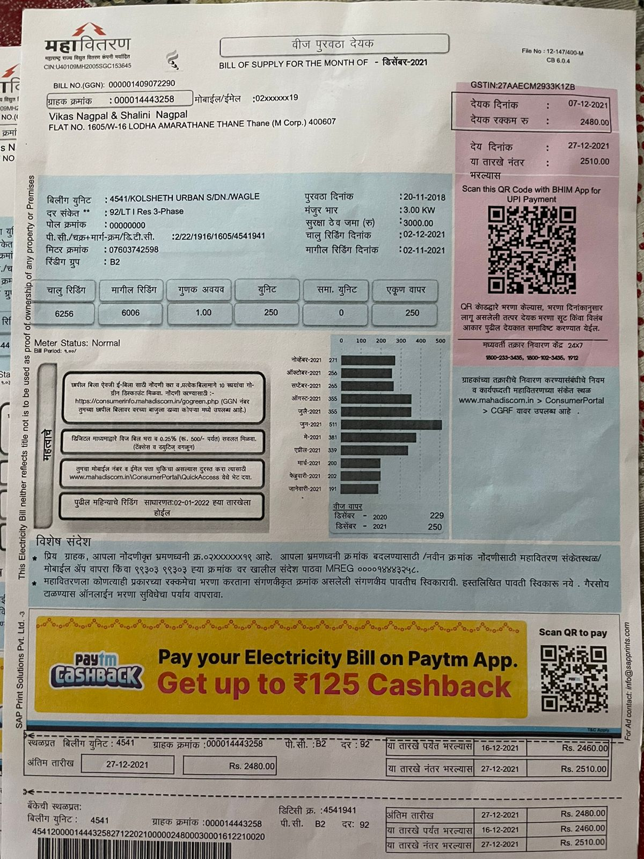

FOR JANUARY:

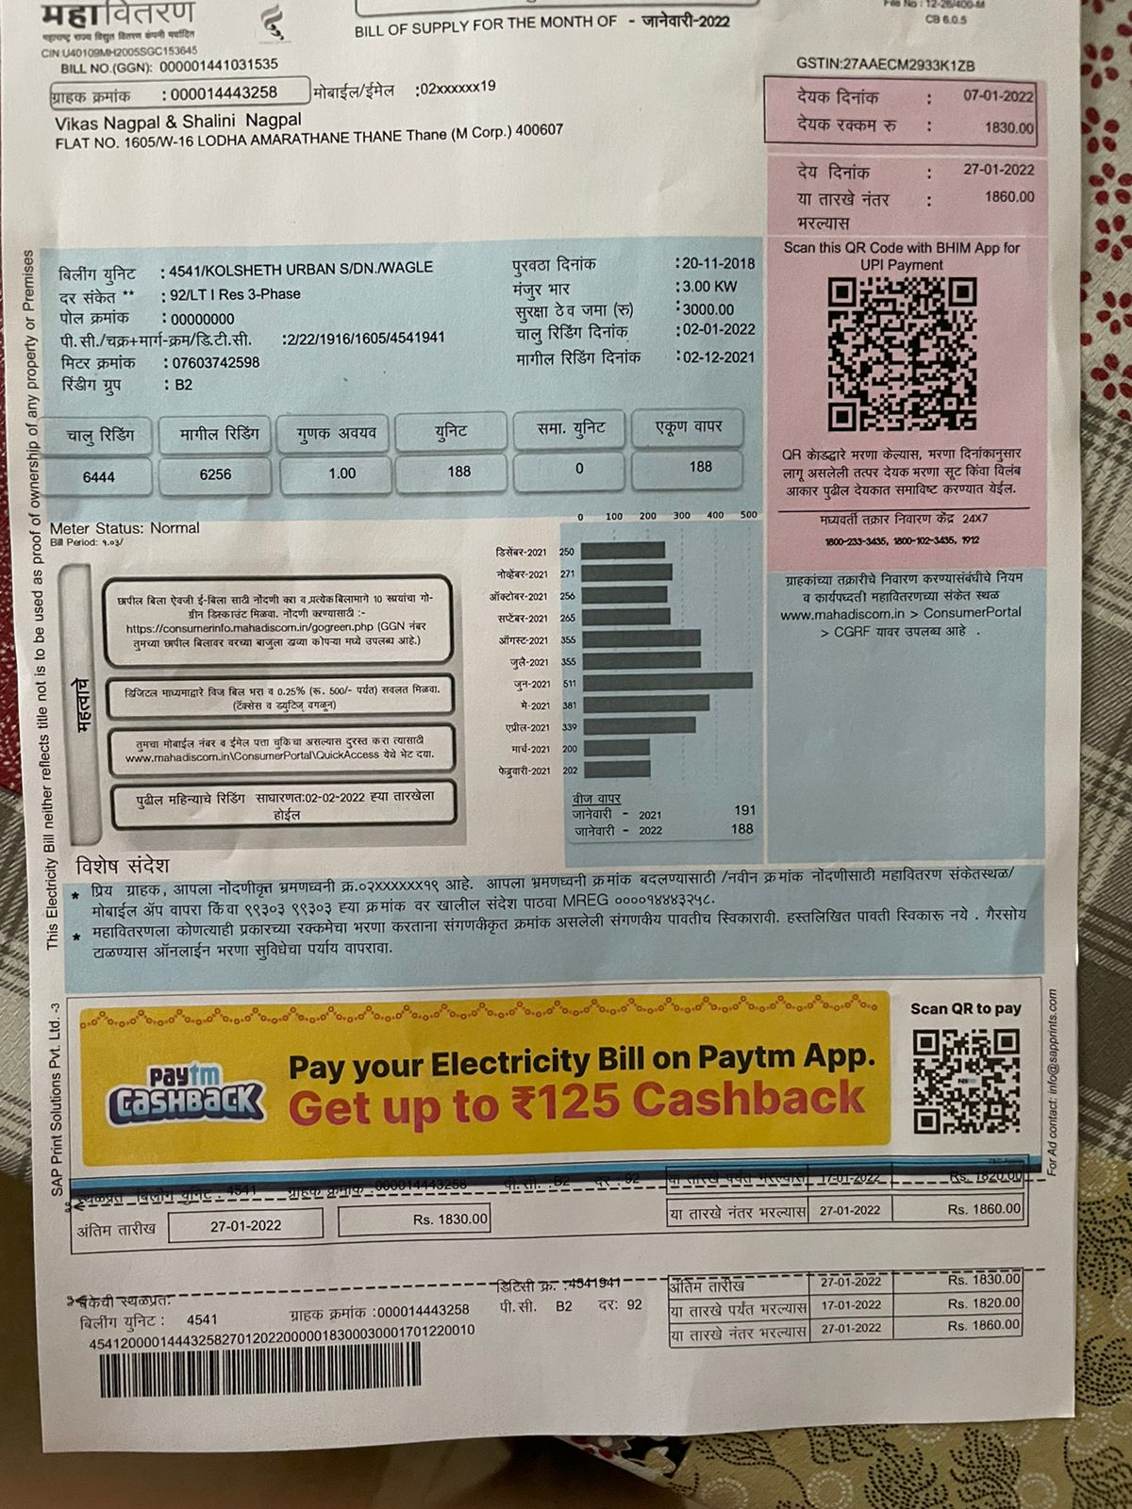

**5. How you can reduce electrical energy consumption of your home? Alternative’s methods.**

**Ans.**

Here are 11 ways to start conserving energy yourself:

1. Replace your light bulbs By CFL Or LED, They Use Much Less Power and Provide Better Luminosity.
2. Install Automatic Light Sensors or Timed Sensors on Outdoor Lighting.
3. Make Your Refrigerator More Efficient: Setting Your Refrigerator’s Temperature Controls to As Close To 37 Degrees to Reduce the Energy.
4. Unplug Electronic Devices When Not in Use.
5. Buy 5-Star Energy Rated Appliances, They Might Be Costly but Use A Lot Less Energy As Compared To Its Lower Rated Counterparts.
6. Install Energy Efficient Windows.
7. Add Insulation to Hot Water Lines & The Water Heater.
8. Install Solar-Powered Landscape Lighting.
9. Install A Programmable Thermostat to Save Energy.
10. Use Low-Flow Faucets And Showerheads.
11. Use Cold Water While Taking Showers.

**6. Estimation of electrical energy consumption after alternate methods suggested in step-5.**

|  |  |  |  |  |  |  |
| --- | --- | --- | --- | --- | --- | --- |
| Sr. No. | Appliances | No of appliances | Power Rating (watts) | Utilization in Hours | Energy in kWh (units)/day | Energy units/month |
| 1 | LED lights | 2  1  2  4 | 2  10  7.5  4 | 5  1  5  1 | 0.2  0.01  0.075  0.016 | 6  0.3  2.25  0.48 |
| 2 | 5 Star AC | $$1$$ | 350 | 1 | 0.35 | 10.5 |
| 3 | Fans | 4 | 10 | 12 | 0.12 | 3.6 |
| 4 | Washing Machine | 1 | 200 | 0.5 | 0.1 | 3 |
| 5 | Geysers | 2 | 300 | 2 | 0.6 | 18 |
| 6 | Mixer | 1 | 350 | 0.5 | 0.175 | 5.25 |
| 7 | High Rated Electric Iron | 1 | 150 | 0.5 | 0.075 | 2.25 |
| 8 | Television | 1 | 100 | 5 | 0.5 | 15 |
| 9 | 5 Star Refrigerator | 1 | 100 | 24 | 2.4 | 72 |
| 10 | Laptop | 1 | 45 | 5 | 0.22 | 6.6 |
|  | | Total energy (units/month) | | | | 147.48 |

**Plot the bar graph showing the comparison of consumption of December-2021 & January-2022 with alternate methods suggested**

**7. Energy saving units/month and expenses in Rs/month (after implementation of alternative method suggested in steps 5 & 6)**

**Ans.**

**For December: -**

|  |  |  |  |
| --- | --- | --- | --- |
| Energy consumption | Energy  units/month | Billing Rate  Rs./Unit | Total (Rs) |
| Estimated | 269.5 | 6.33 | 1786.7 |
| Alternate | 147.48 | 6.33 | 929.12 |
| Actual | 250 | 6.33 | 1582.5 |

Energy Saved Per Month: 269.5-147.48=122.02

INR Saved: 1786.7-929.12 = 857.58 INR

**For January: -**

|  |  |  |  |
| --- | --- | --- | --- |
| Energy consumption | Energy  units/month | Billing Rate  Rs./Unit | Total (Rs) |
| Estimated | 207.96 | 6.33 | 1316 |
| Alternate | 147.48 | 6.33 | 930 |
| Actual | 188 | 6.33 | 1190 |

Energy Saved Per Month: 207.96-188 = 19.98 Units

INR Saved: 1316-930 = 386 INR

|  |
| --- |
| **Signature of faculty in-charge with Date:** |